SSA
Föreningen
SVERIGES SÄNDAREAMATÖRER
Swedish member-society of the IARU and the NRAU

VUSHF frequencies in Sweden.

Information 3
Swedish Law 3
50MHz 4
70MHz 5
144MHz 6
432MHz 7
1296MHz 8
2320MHz 10
3400MHz 13
5,7GHz 15
10GHz 16
24GHz 17
47GHz 18
76GHz 19
122GHz 21
134GHz 22
241GHz 23
275 - 3000 GHz 24

Information
Authors to this document are:
Jens, SM6AFV, SSA Microwave Manager
Mats, SM6EAN, SSA VHF Manager (sm6ean@ssa.se)

This document is intended to be a working document for SSA with respect to frequencies above 30MHz. The intention is to bring a snapshot of the status as general information so corrections, comments and improvements can be discussed and added. All comments are welcome and please use the email address (sm6ean@ssa.se) for feedback and input.

The document will (for now) be accessible under the SSA web page (www.ssa.se) under the section “VHF/UHF/SHF”, and the news (“Nyheter”) will be seen.

This document is based upon several public documents from ITU, CEPT and national administrations. Some links have been collected below and this list will be expanded as useful links are identified;

CEPT/ECC
http://www.cept.org/ecc/groups/ecc/wg-fm

ECA table Oct 2013

ECC report 172: http://www.erodocdb.dk/doks/filedownload.aspx?fileid=3860&fileurl=http://www.erodocdb.dk/Docs/doc98/official/Word/ECCREP172.DOC

ECC report 205:
http://www.erodocdb.dk/doks/filedownload.aspx?fileid=4061&fileurl=http://www.erodocdb.dk/Docs/doc98/official/pdf/ECCREP205.PDF

PTS, Sweden
- PTSFS 2013:4
http://www.pts.se/upload/Foreskrifter/Radio/ptsfs-2013_4-undantag-tillstand.pdf
- http://www.pts.se/sv/Nyheter/Radio/2012/PTS-uppdaterar-sin-plan-for-tilldelning-av-spektrum-de-narmaste-aren/
- http://www.pts.se/upload/Foreskrifter/Radio/ptsfs-2011-2-allmanna-rad-frekvensplanen.pdf

Swedish Law
- Lag (2003:389) om elektronisk kommunikation https://lagen.nu/2003:389

50MHz

Current status
Sweden: 50-52MHz, 200W, Primarily Land Mobile, Amateur secondary
SSA have had discussion with PTS on higher power. Russia have requested lower power.

CEPT: 50-52MHz, Primarily Land Mobile, Amateur secondary

Issues
No known issues.

Target condition

Action plan

70MHz

Current status
Sweden: PTS view is that this is a primary Land Mobile and Fixed radio and this is not an amateur radio band in Sweden. Temporary permits on individual channels, depending on geography, can be issued.

SSA: IARU document presented to PTS.

IARU: 69,9 – 70,5.
IARU will present input paper (Revision of ECA concerning the band 69.9 - 70.5 MHz) at the CEPT WG FM October 2014 meeting in Sofia Antipolis, France. Proposal: “WGFM is invited to consider including a secondary allocation to the Amateur Service in the band 69.9 – 70.5 MHz with a modification to EU9 in the next revision of the ECA.”
Current EU9:” In a growing number of CEPT countries, parts of the band 70.0-70.5 MHz are also allocated to the Amateur service on a secondary basis.”
Proposed change: “CEPT countries may authorize all or parts of the band 69.9-70.5 MHz to the Amateur service on a secondary basis.”

Allocations in some countries: http://www.iaru-r1.org/index.php?option=com_content&view=article&id=172&Itemid=125

CEPT: Primary: Fixed and Mobile. Paired. Amateur radio in ERC Rep025, footnote EU9, parts of 70,0-70,5MHz.

Issues
PTS see 70MHz as a non-amateur radio band.

Target condition
Some channels should be available for Swedish amateurs.
VHF Managers Handbook (rev 6.12): 70-70.5MHz

Action plan
IARU R1 proposal at CEPT WG FM.

144MHz

Current status
Sweden: 144-146MHz. 1000W. Primary user.

CEPT: 144-146MHz. Amateur and amateur satellite primary user.

Issues
No known issues.

Target condition

Action plan

432MHz

Current status
Sweden: 432-438MHz, 1000W. Primary user.

CEPT: 430-440MHz. Amateur and amateur satellite primary user.

WRC: CPG15-PTA4, AI10:” to review the allocations in frequency bands between 410 – 960 MHz in order to enable the development and introduction of new mobile and fixed wideband applications, and if necessary consider additional spectrum allocations, in accordance with Resolution YYY (WRC-15)”

Issues
No known issues.

Target condition

Action plan

1296MHz

Current status
Sweden:1240-1300MHz, 1000W. Radio localisation, Radio navigation primary users. Amateur secondary user.

CEPT: 1240-1300MHz. Earth exploration-satellite and radiolocation primary users. Amateur secondary user.

WRC: Current amateur bands outside of WRC15 discussions.

Issue
Foreseen issue regarding co-location with navigation satellites (GNSS) and high power amateur radio stations.

GNSS: China: Compass ~1268 MHz centre +/-
Europe: Galileo allocated 1260-1300 (primary user)
The commercial service is realized with two additional signals in the 1278.75 MHz band plus also the capability to include commercial data within the open signals.
The Public Regulated Service is realized by two signals, one in the 1575.42 MHz band and the other in the 1278.75 MHz band. These signals are encrypted, allowing the implementation of an access control scheme.
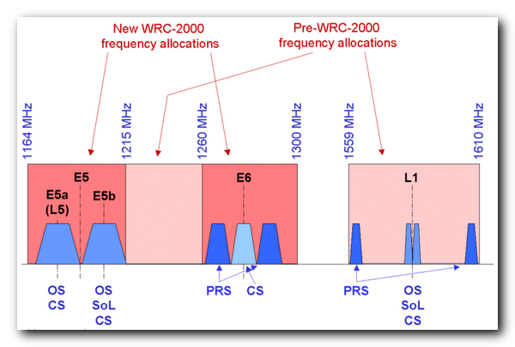
Japan: QZSS ~1260-1300 MHz similar to Galileo-E6
Russia: GLONASS 1237-1260 (primary user)

CEPT: GLONASS Within the band 1237.8-1253.8 MHz
Galileo Within the band 1260-1300 MHz

IARU: Note that whilst GNSS is Primary, the Radiolocation Service (Radars) have greatest priority. This results in weak GNSS signal levels that unfortunately make them vulnerable to wide bandwidth interference sources (such as ATV Transmitters)

Target condition
IARU R1 meeting in September 2014 will discuss proposal (VA14_C5_36) of new allocation. Draft proposed allocation is 1300-1310MHz an input will be prepared for WRC-2018.
Sweden: 1300-1350 Military, radio location,

Action plan
T.b.d. at IARU R1 September meeting.

2320MHz

Current status
Sweden: 2400-2450MHz, max 100mW fed to antenna. (PTSFS 2013:4)
- PTS issue temporary permits 2320-2321 MHz, 1000W.

CEPT: 2300-2450MHz. Fixed and mobile allocation primary users.

Issue
Short summary Sweden: The band 2300 – 2400 MHz is proposed to be reallocated into 20 blocks of 5MHz have access to the band through a Licensed Shared Access (LSA) approach (a new ECC report 205). In addition, license exempt users shall be provided access and coexistence as long as certain Quality of Service can be maintained (ECC Report 172) for licensed users.
(Note by authors: This summary text shall be reviewed after CEPT FM52 meetings and conclusions.)

Sweden:
- Regulation to 100mW in the band 2400-2450. Currently temporary licenses for high power are issued in 2320-2321MHz.
- PTS looking for commercial block allocation and use of the band 2300-2400MHz.
- Until the block is allocated, temporary max 6 month high power permits can be issued. PTS will not change this length of permit due to Swedish law (LEK Chap 3, §12, §12a).
- When the band is allocated, PTS may issue amateur radio permits if agreement for co-existence can be achieved between radio amateurs and the new block allocation owner.

EC:
- Radio Spectrum Policy Group (RSPG) on the band 2300-2400MHz:
“A regulatory approach aiming to facilitate the introduction of radiocommunication systems operated by a limited number of licensees under an individual licensing regime in a frequency band already assigned or expected to be assigned to one or more incumbent users. Under the Licensed Shared Access (LSA) approach, the additional users are authorised to use the spectrum (or part of the spectrum) in accordance with sharing rules included in their rights of use of spectrum, thereby allowing all the authorized users, including incumbents, to provide a certain Quality of Service (QoS)”
https://circabc.europa.eu/sd/d/3958ecef-c25e-4e4f-8e3b-469d1db6bc07/RSPG13-538_RSPG-Opinion-on-LSA%20.pdf

CEPT:
- CEPT/ECC working group FM52 is working on a new ECC Decision “Harmonised technical and regulatory conditions for the use of the band 2300 – 2400 MHz for MFCN” (MFCN = fixed/mobile communication network). “This ECC Decision aims at harmonising implementation measures for fixed/mobile communication network (MFCN) (including broadband wireless systems) in the frequency band 2300-2400 MHz including the least restrictive technical conditions (LRTC), taking into account the existing standardisation framework and activities at the worldwide level, and an appropriate frequency arrangement.”
So far 5 meeting have been held and the plan is two additional meetings to finalise the ECC Decision (FM52-M6 - 08-09 January – France and FM52-M7 - 06-07 May – Italy). LSA means Licensed Shared Access and is/will be covered in ECC Report 205 (Note: This draft is right now under study by SSA).
Amateur radio is listed as current secondary user of the band.

- Sample chapters from the draft ECC decision document:

“LSA is the recognised approach by CEPT for administrations wishing to maintain current incumbent use. Necessary requirements are to be established by the national regulators to share the band through LSA, assessing the protection of the incumbent use of the band.”
“LSA is further described in ECC Report 205. It allows a detailed management of network deployment and effective control of the sharing arrangement, as opposed to licence-exempt regulatory approach. A key feature of LSA is that it allows offering a predictable quality of service for the incumbent as well as for the LSA licensee when each has exclusive access to that spectrum at a given location and at a given time.”
Harmonised Frequency arrangement
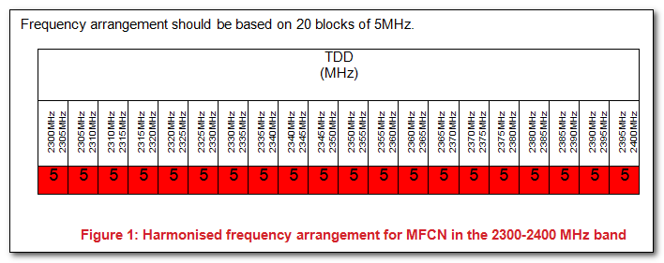

    - Usage scenarios for Amateur service
Amateur radio is a secondary service.
The operational characteristics of amateur stations operating in the 2300–2400 MHz range vary significantly. However based on the IARU Region-1 VHF Managers Handbook Error: Reference source not foundand studies for ECC Report-172, they can be categorised as:
- Long range weak-signal reception of Narrowband Terrestrial (e.g. CW, SSB, digimodes) and EME (Moonbounce) operation - notably in the harmonised sub-band 2320–2322 MHz, including propagation beacons.
- Some additional narrowband activity in the 2300–2305 MHz range, including long range EME (Moonbounce) contacts with North America
- Data, multimedia, and TV repeaters (point-to-point links and area systems) in other parts of the band
Activity levels vary with propagation conditions and peak when national or international contests, or other activity events, are scheduled.

  - Sharing scenarios within the 2300-2400MHz under LSA
Sharing scenarios are summarized in the following sections based upon the sharing studies reported in ECC Report 172Error: Reference source not found. LSA provides additional opportunities for geographic separation for co-frequency operation, or frequency separation for geographic co-location, depending on the incumbent use.

Administrations wishing to implement MFCN under LSA are strongly advised to conduct national studies in order to get a more efficient sharing and to consider in their studies the impact of MFCN topologies as coexistence between BWS and current users of the band has been studied in ECC Report 172 in a worst-case analysis.

It is important to note that the level of the service that can be delivered by a LSA licensee is dependent on the situation in the band; it will be determined by the usage scenarios of the incumbent(s) and the corresponding sharing framework. QoS, in particular when it comes to coverage, can only be provided through licensed spectrum where LSA Licensees have full control/knowledge of the interference they face, and therefore have full understanding of the performance that will be delivered by their network equipment.
    - Coexistence AMATEUR SERVICE with MFCN
ECC Report 172 found that regarding Radio Amateur systems in the 2300-2400 MHz band, operating as a secondary service, it was shown that the required MCL (Minimum Coupling Loss) can be achieved by various mitigation techniques.

Target condition
2320-2321 with high power and 2400-2450 with 100mW (current regulation).

Action plan
- Maintain current wording about amateur radio and sharing in the draft ECC Decision document.
- Clarify if the status “secondary user” or other term for license exempt users will be relevant for the ECC Decision. Amateur radio and other users may preferably be listed as license exempt users. Email sent to IARU FM52 participant.

3400MHz

Current status
Sweden
- TRA-ECS, block in line with 2008/411/EG. Fixed and Mobile Radio, Fixed – satellite.
- PTS issue temporary permits 3400-3401 MHz, 1000W.
  - PTS looking for commercial block allocation and use of the band 3400-3800MHz.
  - Time to allocation is most likely further away than for 2,3 to 2,4GHz.
  - Until the block is allocated, temporary max 6 month high power permits can be issued. PTS will not change this length of permit due to Swedish law (LEK Chap 3, §12, §12a).
  - When the band is allocated, PTS may issue amateur radio permits if agreement for co-existence can be achieved between radio amateurs and the new block allocation owner.

CEPT: 3400-3500MHz. Fixed, satellite and mobile primary users. Amateur secondary basis.
- CEPT ECC Decision ECC/DEC(07)02 defines Broadband Wireless Access (BWA)
  - § k) “…that Radio Amateur Services are authorised in the frequency band 3400-3410 MHz on a secondary basis”
- ERC Report 25, Footnote EU17: In the sub-bands 3400 - 3410 MHz, 5660 - 5670 MHz, 10.36 - 10.37 GHz, 10.45 - 10.46 GHz the amateur service operates on a secondary basis. In making assignments to other services, CEPT administrations are requested wherever possible to maintain these sub-bands in such a way as to facilitate the reception of amateur emissions with minimal power flux densities.

Issues
Sweden:
- 3,4 GHz is not seen as an amateur radio band, contradicting CEPT ECC/DEC(07)02

EC:
- 2014/276/EU: “COMMISSION IMPLEMENTING DECISION”…” on amending Decision 2008/411/EC on harmonisation of the 3400-3800 MHz frequency band for terrestrial systems capable of providing electronic communications services in the Community”
- Key wording “…requires Member States to make available the 3 400-3 800 MHz frequency band under the terms and conditions of Decision 2008/411/EC and, subject to market demand, to authorise the use of this band by 31 December 2012 without prejudice to existing deployments of services and under conditions that allow consumers easy access to wireless broadband services.”

CEPT:
- ECC Decision (11)06 “Harmonised frequency arrangements for mobile/fixed communications networks (MFCN) operating in the bands 3400-3600 MHz and 3600-3800 MHz” (Decision “…CEPT administrations shall designate the frequency bands 3400-3600 MHz and 3600-3800 MHz on a non-exclusive basis to mobile/fixed communications networks (MFCN), without prejudice to the protection and continued operation of other existing users in these bands …”)
- ECC Report 203 “Least Restrictive Technical Conditions suitable for Mobile/Fixed Communication Networks (MFCN), including IMT, in the frequency bands 3400-3600 MHz and 3600-3800 MHz” propose the principals for future use of the band 3400 to 3800 MHz. Amateur radio is not listed as a current user while national administrations do mentions Amateur Radio.
In the report TDD and FDD systems are discussed where a TDD allocation will use the band fully, while a FDD system will have guard bands (e.g. 3400 to 3410 MHz in the lower end).

Target condition
Regulated allocation 3400-3401 MHz or target new allocation outside of 3,4 to 3,8GHz.

Action plan
To be discussed. If FDD allocation in the lower band, Amateur radio may be considered in the 3400 to 3410 MHz guard band. However, TDD is more likely and will most likely not have a guard band like FDD systems.
IARU activity?

5,7GHz

Current status
Sweden 5,65-5,85GHz, 1000W.

CEPT:
- 5,65-5,85GHz. Mobile and radiolocation primary users.
- ERC Report 25, Footnote EU17: In the sub-bands 3400 - 3410 MHz, 5660 - 5670 MHz, 10.36 - 10.37 GHz, 10.45 - 10.46 GHz the amateur service operates on a secondary basis. In making assignments to other services, CEPT administrations are requested wherever possible to maintain these sub-bands in such a way as to facilitate the reception of amateur emissions with minimal power flux densities.
- ERC Report 25, EU23 In the sub-bands 5660-5670 MHz (earth to space), 5830-5850 MHz (space to earth) and 10.45-10.50 GHz the amateur-satellite additionally operates on a secondary and non-interference basis to other services. In making assignments to other services, CEPT administrations are requested wherever possible to maintain these allocations in such a way as to facilitate the reception of amateur emissions with minimal power flux densities.

Issues
EU: Initiative to strengthen and protect the WLAN service has been issued. Basic decision: 2005/513/EC: “The purpose of this Decision is to harmonise the conditions for the availability and efficient use of the frequency bands 5 150-5 350 MHz and 5 470-5 725 MHz for wireless access systems including radio local area networks (WAS/RLANs).”
(Documents regarding extension of the bands??)

WRC: WRC-15
- Action Item 1.1 [450MHz to 6GHz]: to consider additional spectrum allocations to the mobile service on a primary basis and identification of additional frequency bands for International Mobile Telecommunications (IMT) and related regulatory provisions, to facilitate the development of terrestrial mobile broadband applications, in accordance with Resolution 233 [COM6/8] (WRC-12)

PTS:
- Action Item 1.1
  - [5725 to 5850 MHZ] Sweden support studies of for broadband “RLAN” low power application.

IARU:
- Currently no planned action

Target condition
Tbd

Action plan
IARU action?

10GHz

Current status
Sweden 10,0-10,5GHz, 1000W. Fixed, mobile and radiolocation primary users. Amateur secondary.
- PTS decision Dnr: 11-4937, 2011-12-09. 10210−10294 and 10560−10644 MHz allocated for
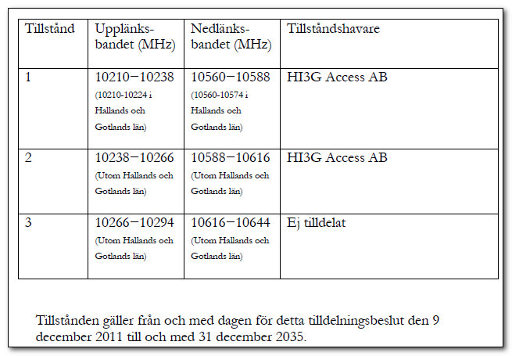
- FMV and Swedish Defense is currently using the bands 8500-10210 MHz and 10294-10500 MHz for radar, and will be doing so for foreseeable future. Propose to ITU WRC15 to maintain the protection for Radiolocation and Radio navigation in the bands.

CEPT: 10,0-10,5GHz. Fixed, mobile and radiolocation primary users. Amateur secondary.

Issues
Sweden:
- New commercial radio link sub-bands proposed, implementation unclear. The narrowband activity centres are currently untouched.

WRC: WRC15
- Action Item 1.12: to consider an extension of the current worldwide allocation to the Earth exploration-satellite (active) service in the frequency band 9 300-9 900 MHz by up to 600 MHz within the frequency bands 8 700-9 300 MHz and/or 9 900-10 500 MHz, in accordance with Resolution 651 [COM6/18] (WRC-12);

Target condition
If discussions arise, a proposal may be to follow the ERC Report 25, Footnote EU17 and EU23 with the sub-bands 10.36 - 10.37 GHz and 10.45-10.50 GHz.

Action plan
Tbd

24GHz

Current status
Sweden
- 24,0-24,05GHz, 1000W. Primary use Amateur radio.
- 24.05-24.52 GHz Radio localisation primary user, Amateur secondary user.

CEPT:
- 24,0-24,05GHz. Amateur and amateur satellite primary users.
- 24,05-24,25GHz Radiolocation primary user.

Issues
WRC: WRC15
- Action Item 1.10: to consider spectrum requirements and possible additional spectrum allocations for the mobile-satellite service in the Earth-to-space and space-to-Earth directions, including the satellite component for broadband applications, including International Mobile Telecommunications (IMT), within the frequency range from 22 GHz to 26 GHz, in accordance with Resolution 234 [COM6/16] (WRC-12)
PTS
- Studies of future needs and sharing is required before any decision can be taken.

CEPT
- CEPT sees difficulties, in particular in sharing, for MSS allocations within the frequency range 22-26 GHz and does not support such additional allocations under this Agenda Item. Further to this agenda item CEPT does not see a need for additional spectrum and therefore requests justification for possible spectrum allocations for the MSS in the band 22-26 GHz.

Target condition
Secure a primary segment for Amateur radio

Action plan
IARU proposal (VA14_C5_07) to re-organize the IARU band plan using the primary segment also for wide band usage.

47GHz

Current status
Sweden 47,0-47,2GHz, 1000W. Primary use amateur radio

CEPT: 47,0-47,2GHz. Amateur and amateur satellite primary users.

Issues
No known issues.

Target condition

Action plan

76GHz

Current status
Sweden
- 75,5-81,0GHz, 1000W.
  - Amateur radio primary user 77,5-78 GHz, secondary elsewhere in the band.
- Radio astronomy and radio location primary users 76,0-77,5 GHz

IARU
- Proposed activity center 75976.2 MHz (used in the UK). 76032.200 narrow band center in some countries (not preferred)

CEPT:
- 75,5-77,5GHz. Amateur secondary user.
- 77,5-78 GHz Amateur primary user.
- 78,0-81,0GHz. Amateur secondary user.

Issues
Sweden
- Public request around commercial allocation for 70/80 GHz band, and possible re-allocation of other services into the 76-77 GHz sub-band.

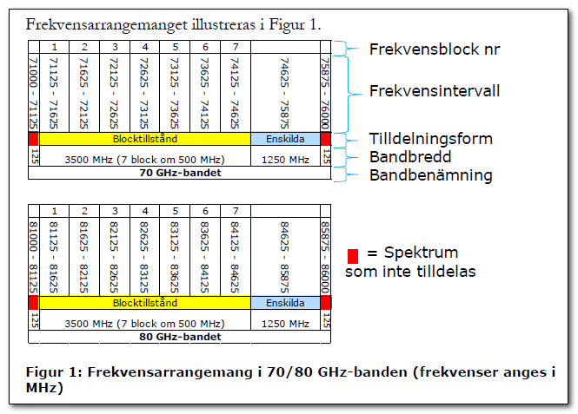

Re-allocation:
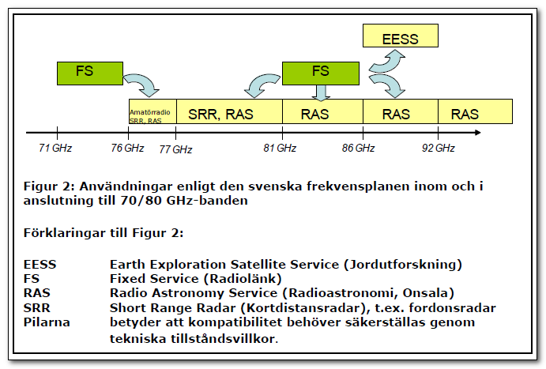

Target condition
To be discussed at IARU R1 September 2014 meeting (proposal VA14_C5_33).

Action plan
Discussion regarding IARU to propose to CEPT of a re-allocation of current Amateur primary segment (77,5-78 GHz) to a new primary segment (75,5-76GHz) to avoid automotive radar services. To be discussed at IARU R1 September meeting.

122GHz

Current status
Sweden 122,25-123,0GHz, 1000W. Amateur secondary.

CEPT: 122,25-123,0GHz. Fixed and Mobile primary user. Amateur secondary user.

Issues
No known issue.

Target condition

Action plan

134GHz

Current status
Sweden 134,0-141,0GHz, 1000W.
- 134,0-136,0GHz. Amateur primary user.
- 136,0-141,0GHz. Amateur secondary user.

CEPT:
- 134,0-136,0GHz. Fixed Amateur primary user.
- 136,0-141,0GHz. Fixed Amateur secondary user.

Issues
No issues known

Target condition

Action plan

241GHz

Current status
Sweden 241,0-250,0GHz, 1000W.
- 241-246,0GHz. Amateur secondary user
- 248,0-250,0GHz. Amateur primary user.

CEPT:
- 241-246,0GHz. Amateur secondary user
- 248,0-250,0GHz. Amateur primary user.

Issues
No issues known

Target condition

Action plan

275 - 3000 GHz

Current status
Sweden: No information
CEPT: Not allocated. May be used by both active and passive services

